Tribute to Patricia Bowen-West (1926 – 2022)  IAPESGW President 1989 - 1997  Honorary Life Member of IAPESGW (1997)  By Rosa Diketmüller (IAPESGW) | 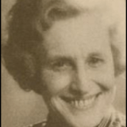

Patricia Bowen-West was born in 1926 in United Kingdom and trained as a teacher at Bedford College of Physical Education, qualifying in 1946. She undertook further study in the 1960s at the Laban Art of Movement Centre, and at the London University Institute of Education, where she took a post-graduate Diploma Course in the Philosophy of Education.
After a initial teaching experience in a school, she appointed Physical Education advisor to Kent Local Education Authority in 1953. Between 1955-1971, she was a Lecturer at the Manchester College of Education, then Furzedown College, and finally Principal Lecturer AT Bishop Lonsdale College of Education. She played a significant role in the development of teacher training courses. This led to her appointment as Principal of Bedford College of Physical Education, her alma mater, in 1971. In 1976 she became Deputy Director of Bedford College of Higher Education. Sheila Fletcher wrote about her: “ Temperamentally, and for her own experience, Pat Bowen-West was a notable survivor: She had done what was relatively rare in the fifties: combine a career with marriage and motherhood. She had been widowed young, with young children.’ (in Hall & Pfister, 1999, p. 72). She remained at Bedford until her retirement in 1986. Bedford honoured her with naming a new theatre after Patricia Bowen-West.
She served as well on many committees at the regional and national level including the Minister’s Working Party on Centers of Excellence in Sport, and she was chair of the physical Education Committee of the Association of Teachers in colleges and Departments of Education. For her significant contribution to physical education, Bowen-West was appointed an officer of the Order of the British Empire in 1984.

Bowen-West became a member of IAPESGW in 1969 and was the UK representative from 1979 to 1985. She has attended the congresses in Teheran, Buenos Aires, Bali, Melbourne, Lahti and Smith College. In 1985, she chaired the organizing committee for the superbly run tenth congress in Warwick. In 1985 she was elected as vice-president and responsible among other things, for setting up the Dorothy Sears Ainsworth Award, and for liasing with the organizers of the next congress in Bali.
In 1989 she took over the presidency of IAPESGW from Helene Tollich. Her initiatives as president were to build on her predecessor’s team approach by developing guidelines to assist the Council of Representatives, and renewing the role of the Board of Consultants. She also tried to make IAPESGW more visible by intensifying cooperation with ICSSPE by, for example, organizing symposia during the ICSSPE pre-Olympic congresses in Malaga in 1992 and Dallas in 1996. However, IAPESGW was faced during the presidency of Bowen-West with competition from other groups, more advocacy-oriented and political, within the emerging global women’s sport movement.

In 1997, Bowen-West was awarded honorary membership in IAPESGW as well as in ICSSPE
‘… She gracefully steered IAPESGW into an open and democratic style of operation and succeeded n always creating an atmosphere of mutual trust and respect. Where ever she represented IAPESGW, she earned the admiration of all for her dignity, wisdom and well-spoken presentations leaving members with a great sense of pride’ (Bulletin of IAPESGW, 8(1), 1998, p. 5-6)

Patrick Bowen-West was known to enjoy an active retirement and died in January 2022 in the age of 96. I had the privilege to meet her at two conferences in Lahti in 1997 and at Smith College 1999. I was deeply impressed by her style and her ambition in empowering girls and women in Physical Education and Sport worldwide. And I am quite sure, that Pat Bowen-West was - not only for me - one of the most influential role models and global advisor for Physical Education and Sport for Girls and Women globally.

Pat, your legacy, and your memory will be with us forever.
Rest in peace!

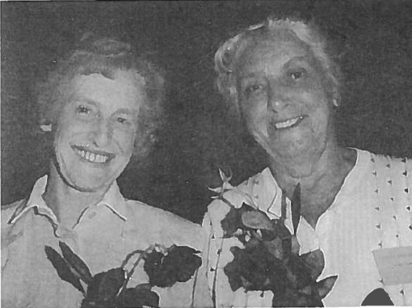 Patricia Bowen-West together with Audrey Bambra in CapeTown 1977 | 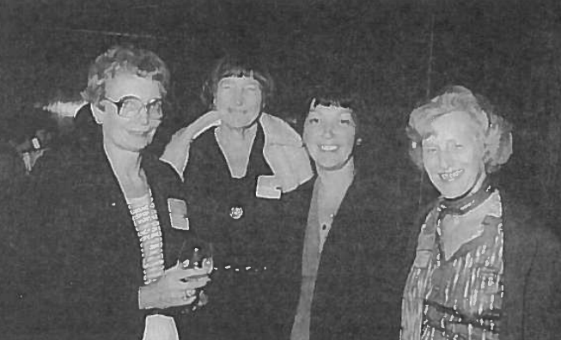  Patricia Bowen- West 1981 in Buenos Aires together with Mette Winkler, Bede Barfood und Margaret Talbot (Hall & Pfister, 1999, p.25)

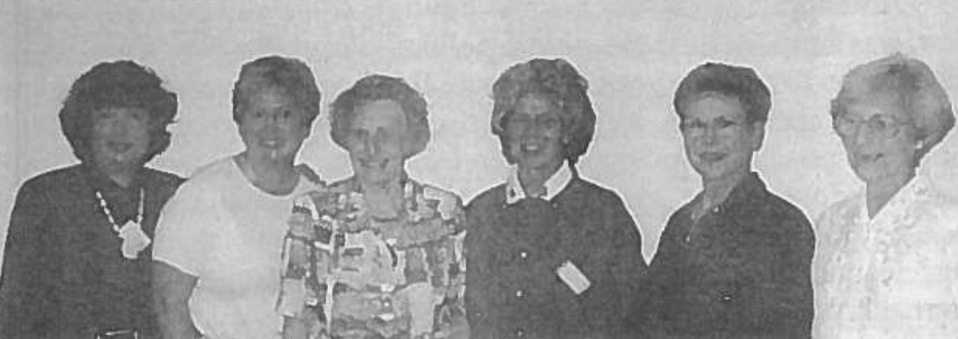
Patricia Bowen- West within her Executive Board 1993-1997: Atara Sherman, Janet Grier, Pat, Arnevi Lassila, Julika Ullmann, Edith Katzenellenbogen (missing Margaret Talbot; Hall & Pfister, 1999, p. 34)

Sources
Hall, A. & Pfister, G. (1999). Honouring the legacy. Fifty Years of the International Association of Physical Education and Sport for Girls and Women. Online: https://iapesgw.com/wp-content/uploads/2020/04/iapesgw-hall-pfister-1999.pdf

